# LAB 2 for Operating System

***Name****: TRẦN THANH DƯƠNG*

***Code****: SE160185*

***Class****: AI1601*

## **Present the content of manipulating of some command**

* **man**: is used to display the user manual of any command that we can run on the terminal

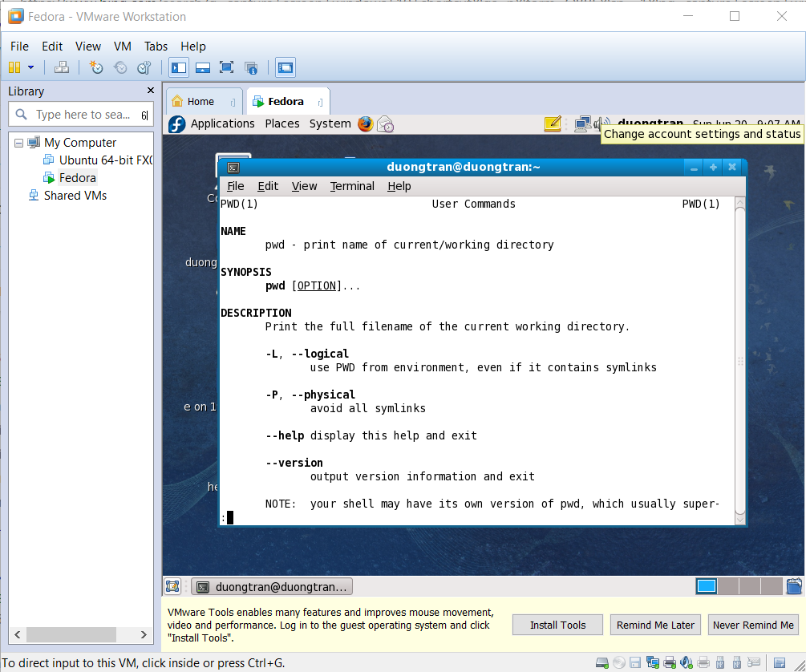

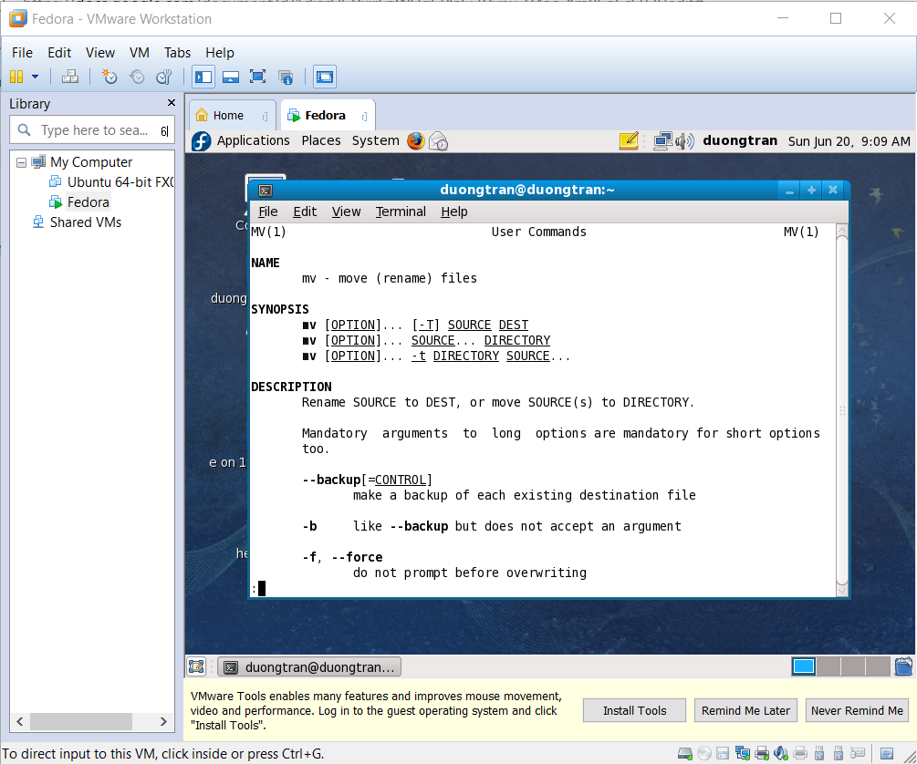

* **bg**: to send a service, which is working in the foreground, to the background using job control.

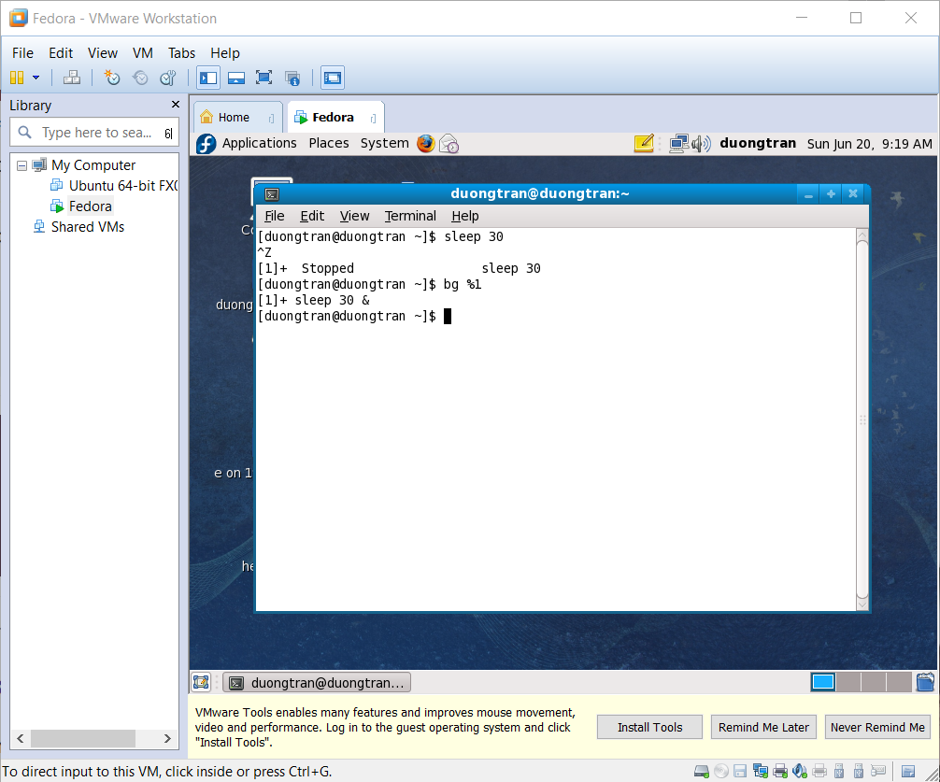

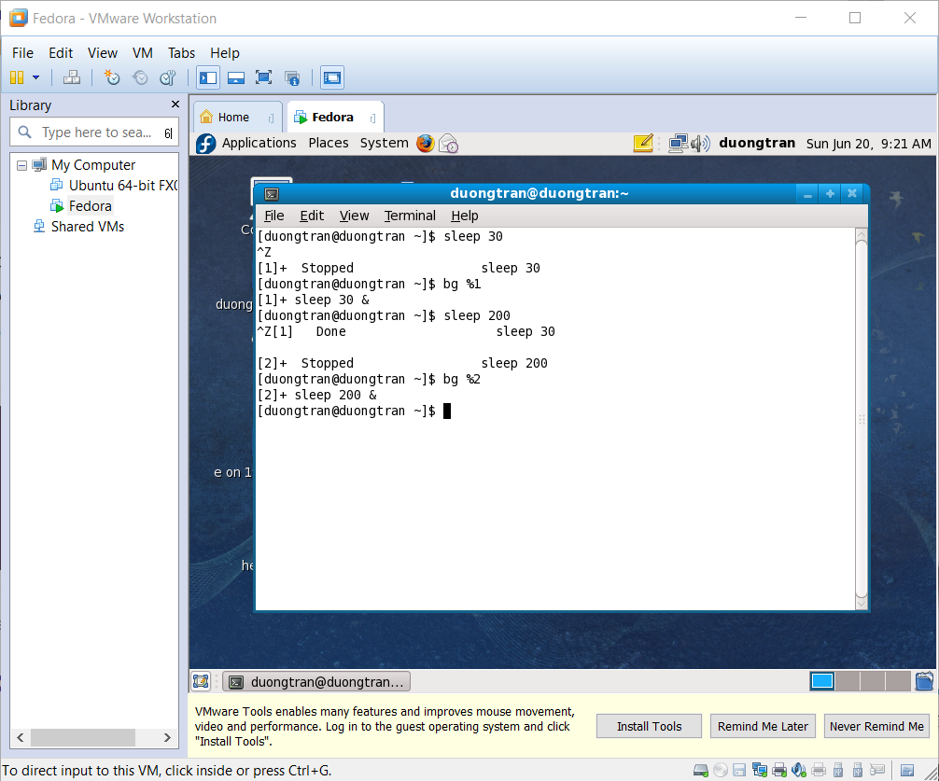

* **fg**: is a command that moves a background process to the foreground.

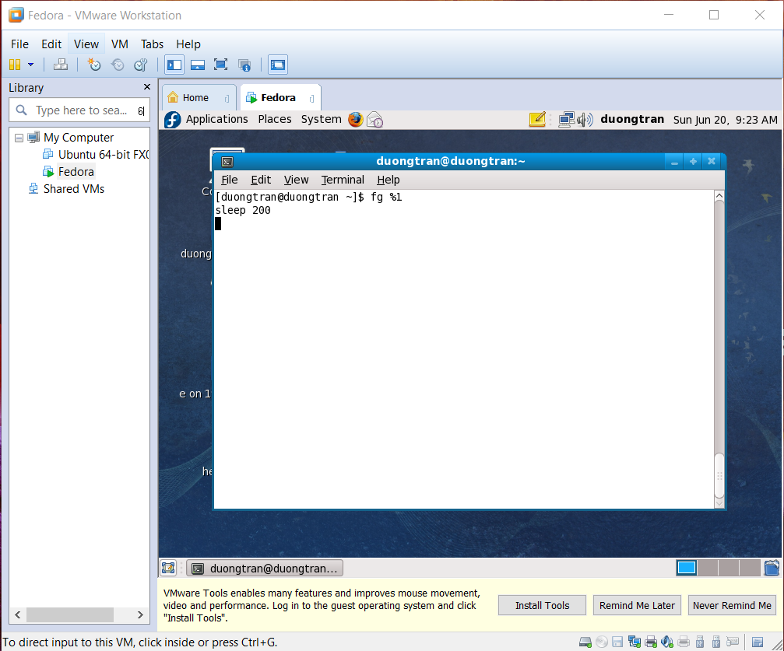

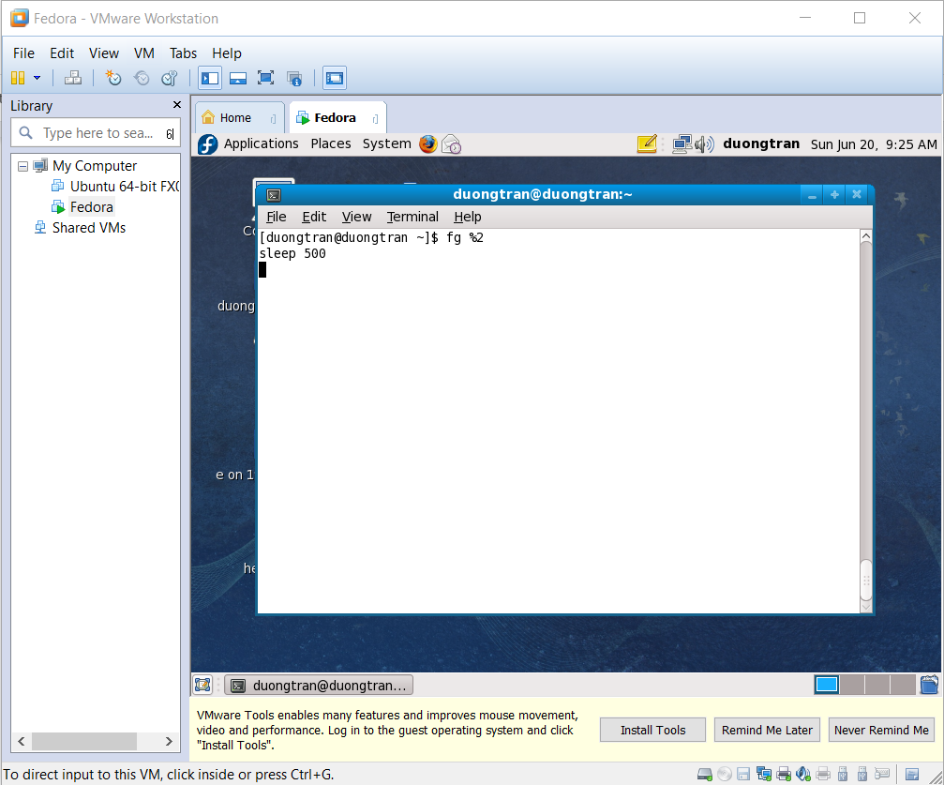

* **chown**: allows you to change the user and/or group ownership of a given file, directory, or symbolic link.

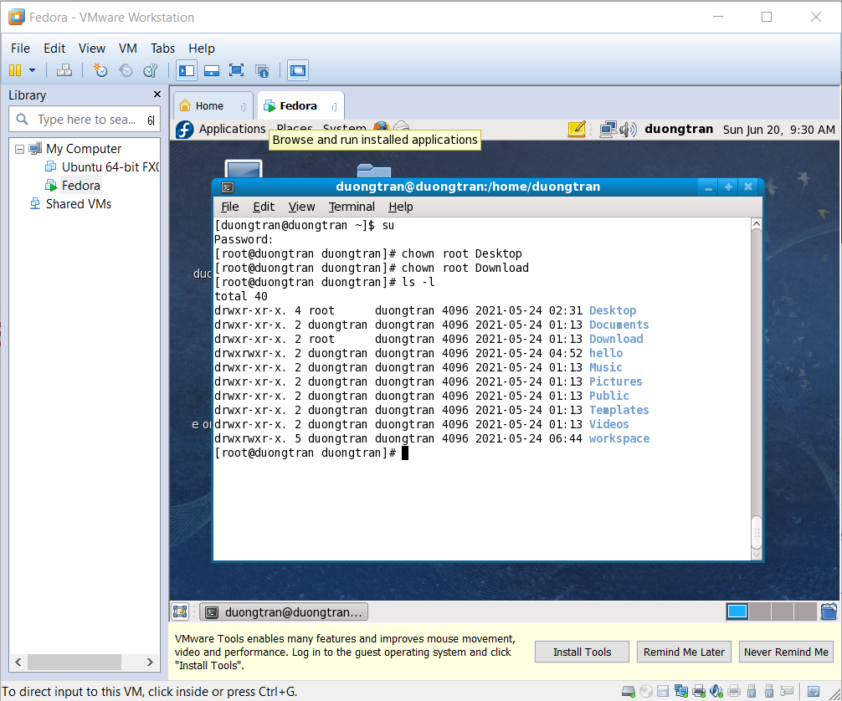

* **chgrp**: To change the group ownership of a file or directory

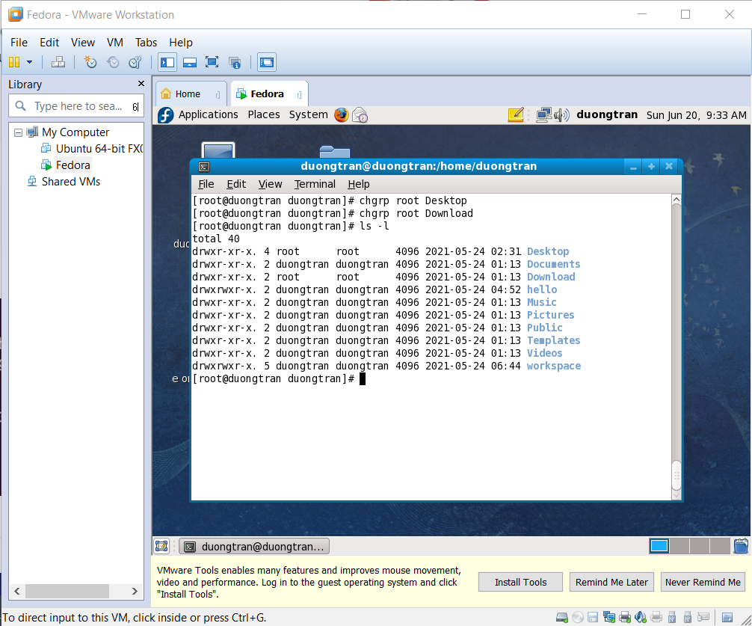

* **chmod**: to change the permission on a file or directory

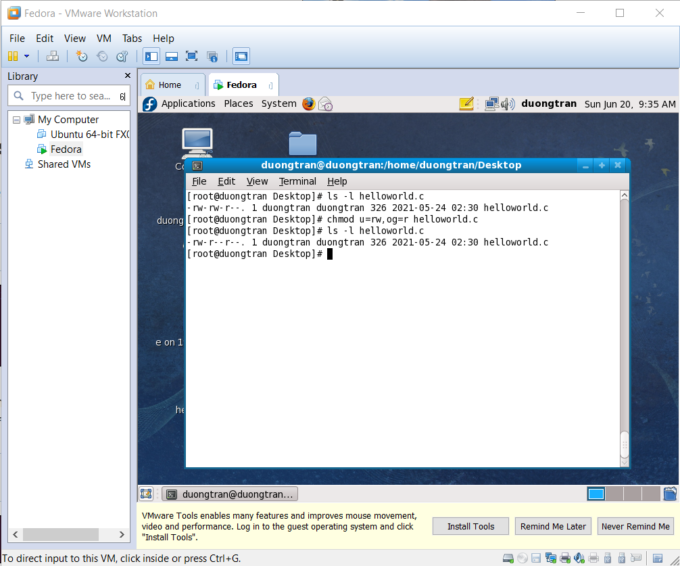

* **date**: displays or sets the system date

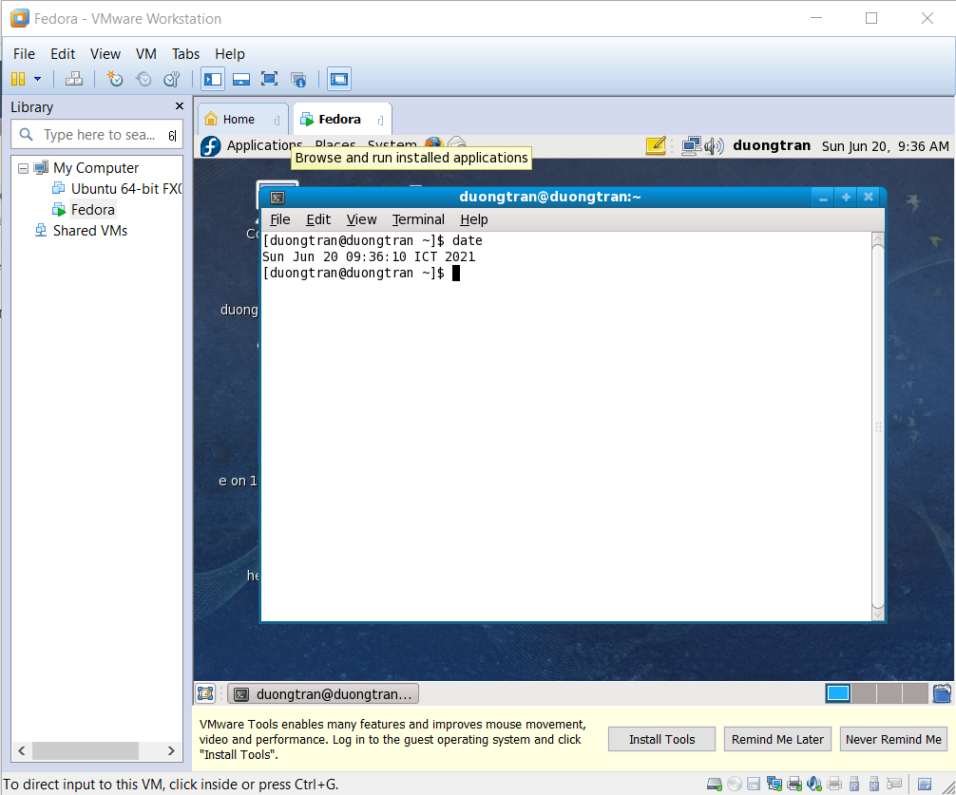

* **su**: is used by a computer user to execute commands with the privileges of another user account.

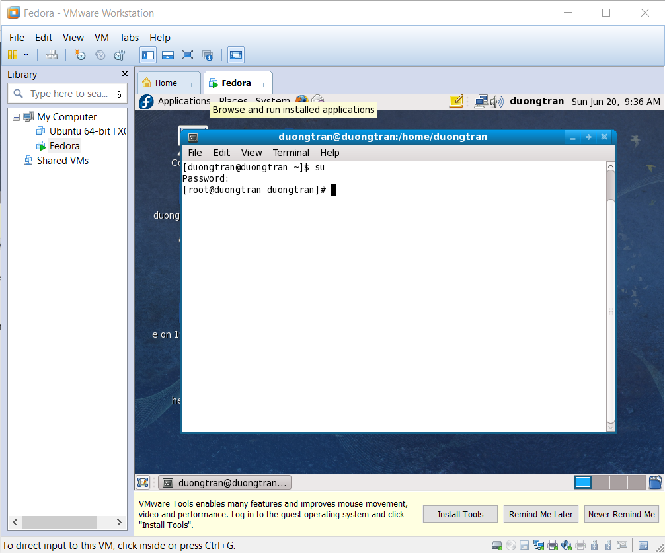

* **top**: shows the running processes within your environment that consume the most system resources.

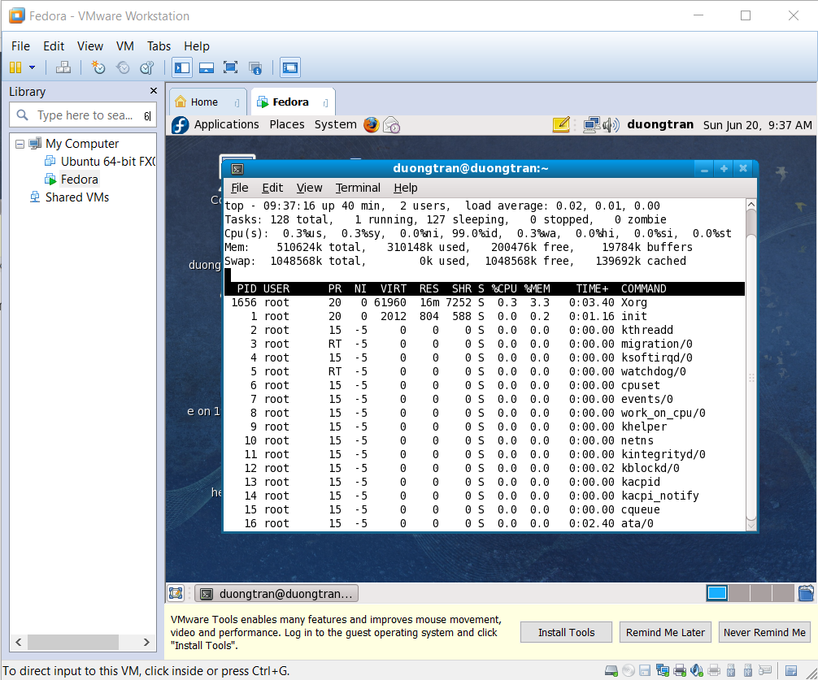

* **kill**: used to terminate processes manually.

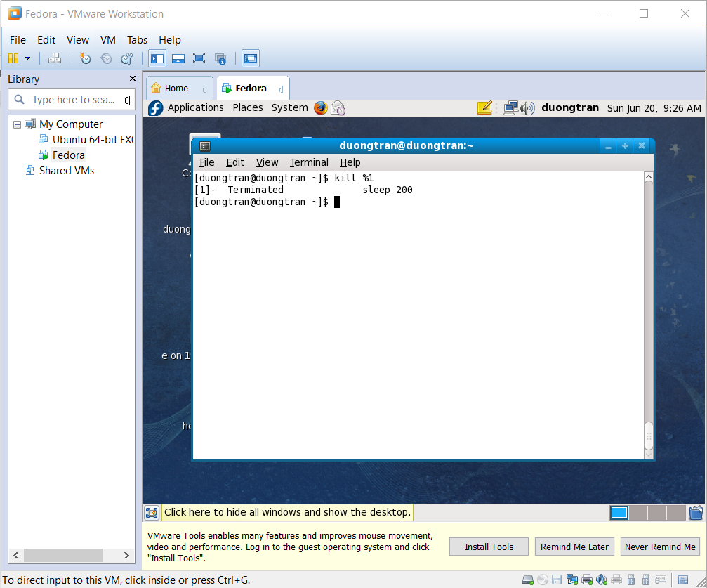

* **jobs**: allows the user to directly interact with processes in the current shell.

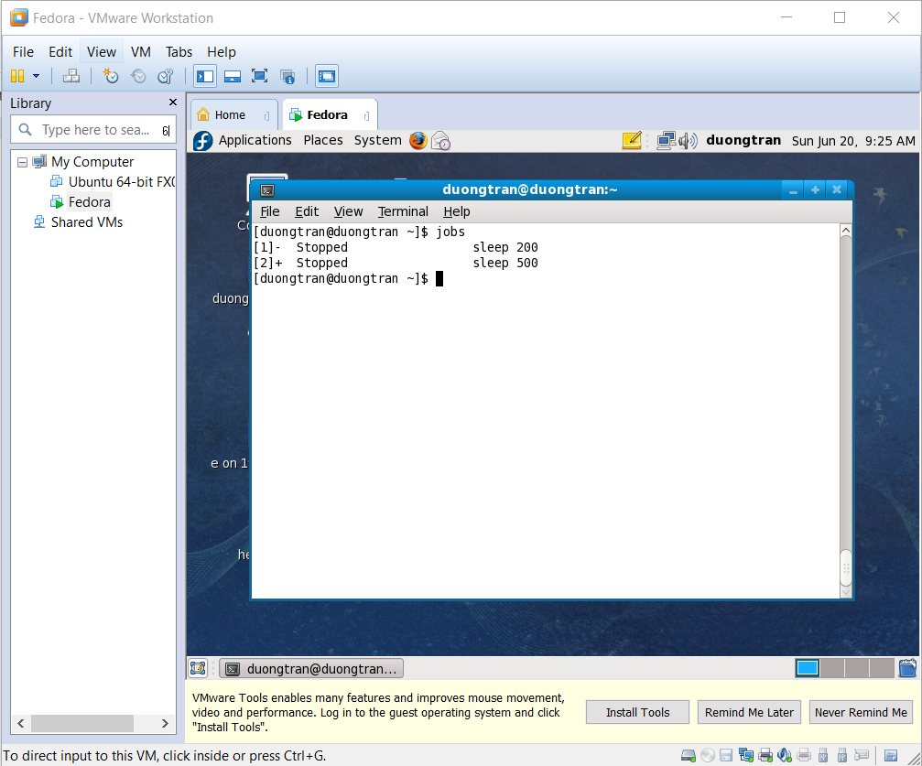

## **Capture the terminal screen using grep**

* **Usage**: Search any line that contains the word in filename.

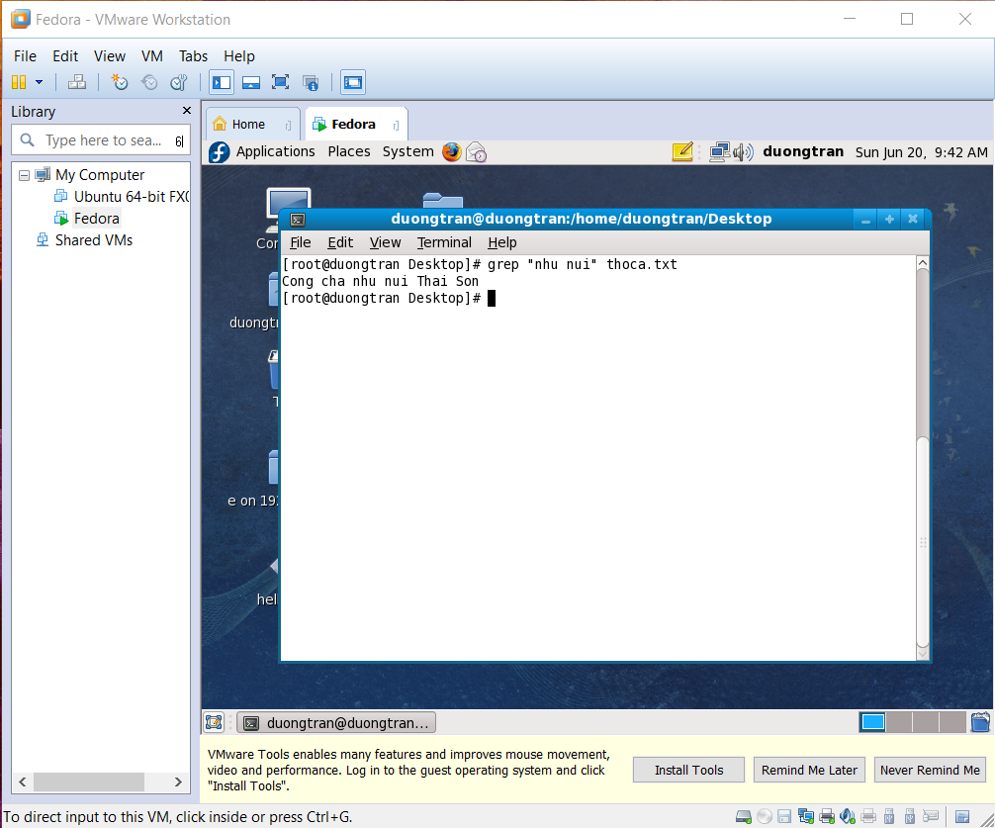

## **Submit C/C++ files**

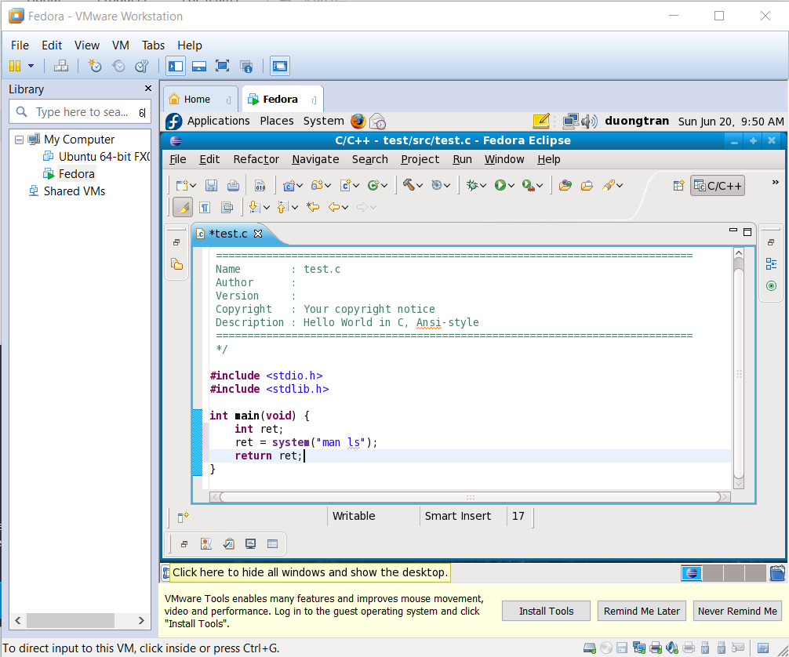

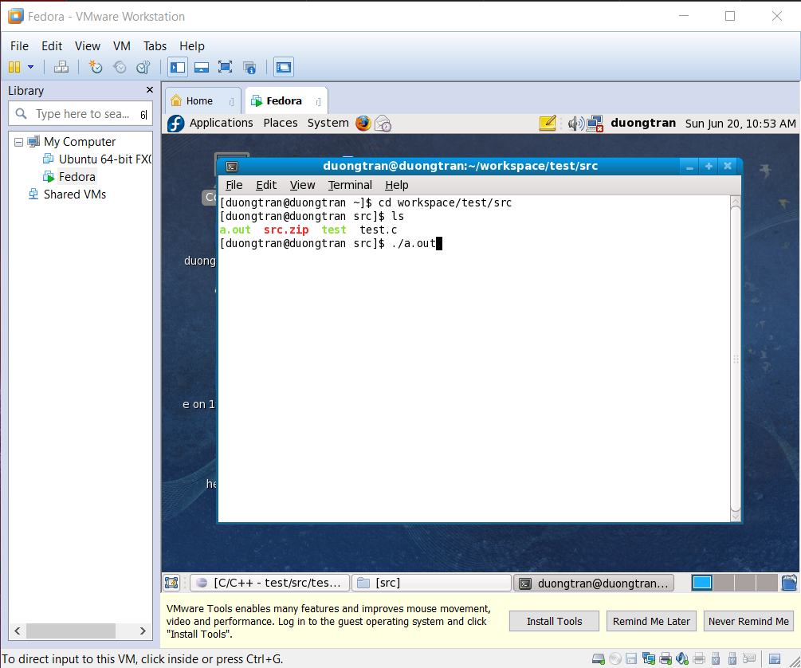

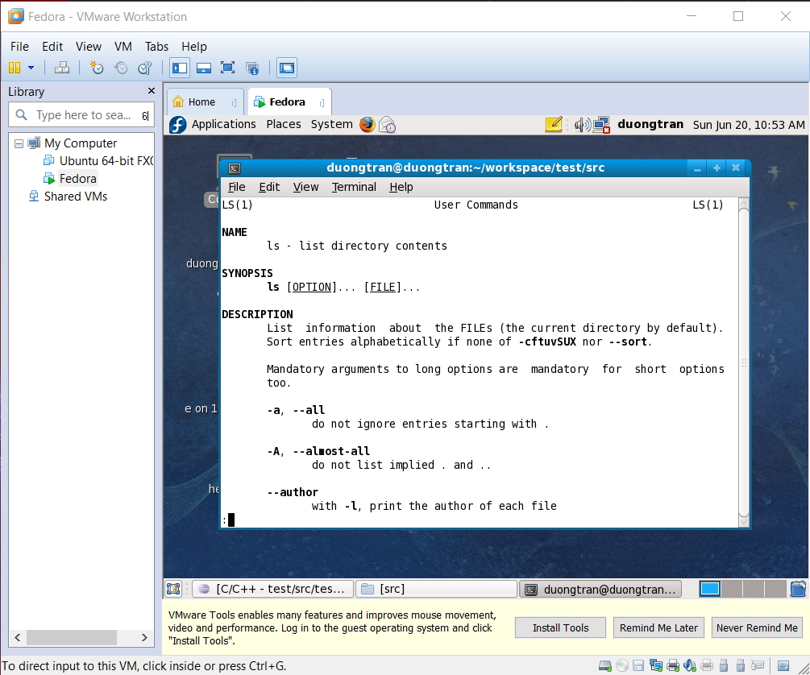

* **Explanation**: This code helps to run the command “man ls” – print out manual page of **“ls” command** like in Terminal window.